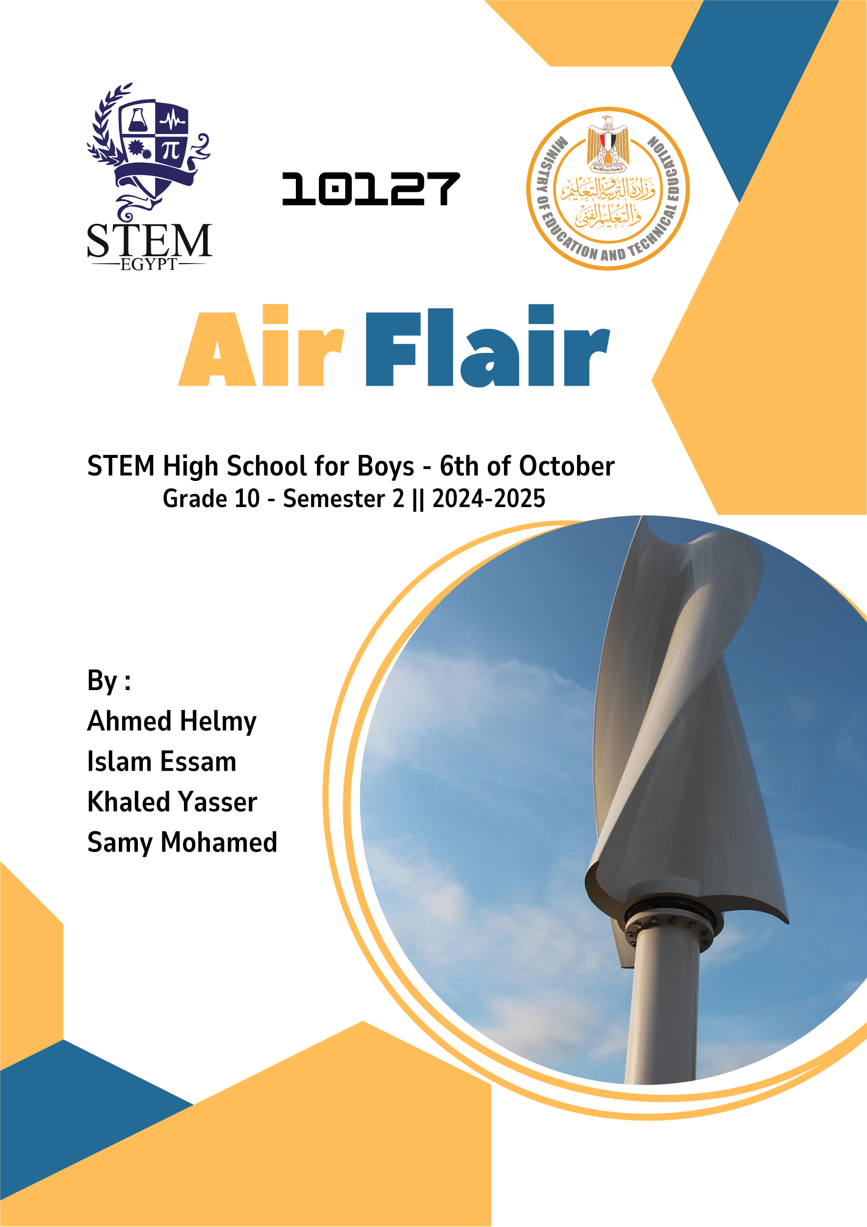
Chapter 1
Contents
Chapter 1 4
Egypt Grand Challenges 5
Improve the use of alternative energies 5
Improve the scientific and technological environment for all 8
Address & reduce pollution in air, water, and soil. 11
Reduce and adapt to the effects of climatic change 15
Work to eradicate public health issues 16
Problem to be solved 19
Research 22
Other solutions already tried. 25
Dogger Bank Wind Farm 25
Benban Solar Park 29
Aswan High Dam 32

Chapter 1

Egypt Grand Challenges

Improve the use of alternative energies

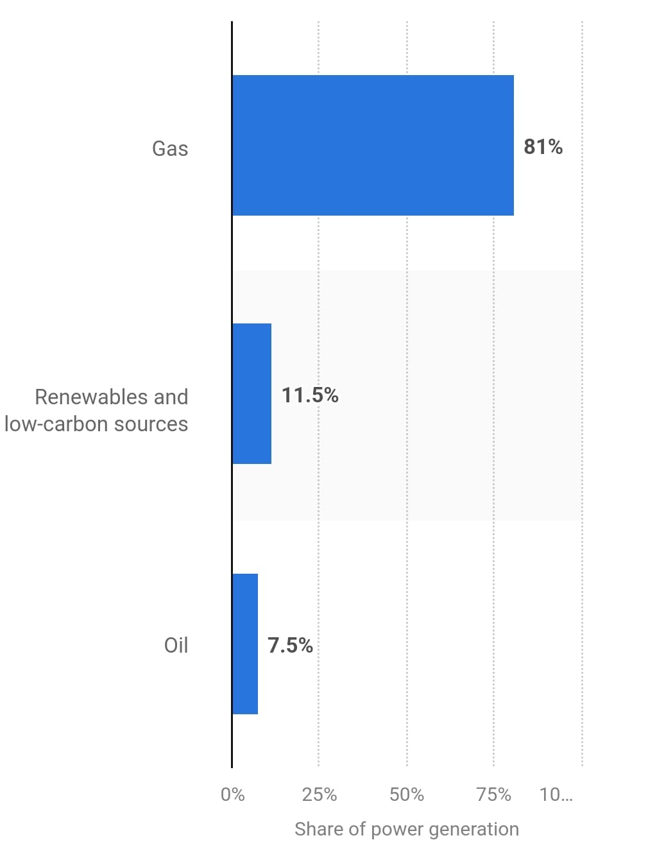
Egypt has several ways of generating electricity. Although Egypt still uses non-renewable sources of energy for main electricity generation. Most of Egypt’s energy comes from fossil fuels, consisting of oil and gas. As illustrated in Figure 1, 81% of power generation in Egypt is from gas, 7.5% from oil, and 11.5% from renewable and low-carbon sources such as wind, solar, and hydropower.
Figure 1
Given that the consumption of energy in Egypt is 1540 kWh of electricity. And energy production in Egypt is around 3,850,000 TJ. The energy production from polluting sources is around 3,380,000 TJ, which is a massive problem as only the CO2 emissions are around 217.806 Megatons reaching 118% increase from 2000 to 2022, and 0.6% of the global emissions according to IEA.
These numbers are frightening as they risk Egypt with many health issues, high increases in petrol and gas prices, and global warming, which are concerning problems for all classes of people.
Causes:
- Abundance of fossil fuel reserves.
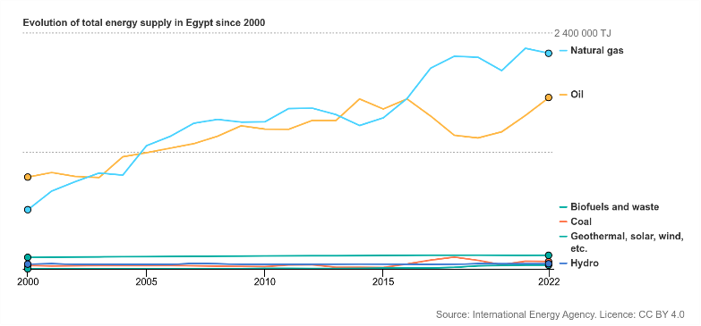
Egypt has many significant reserves of fossil fuels like oil and natural gas, especially in the Mediterranean and the western desert. Egypt ranks 26th with 4,400,000,000 barrels in 2016 with 0.27% of the world’s share of oil reserves, making fossil fuels easily accessible. Egypt has historically invested in fossil fuel extraction, considering the 3.3 billion barrels of oil and the 77.2 trillion cubic feet (tcf) of natural gas at the end of 2018. As shown in Figure 2 Which makes replacement hard and costly.
Figure 2

- Industrial and transportation dependence.
Egypt's industries and transportation depend on non-renewable energy sources, making switching challenging. In 2021, the industries consumed around 611,094 terajoules of energy, accounting for 24.5% of Egypt's total final energy consumption. Transportation was responsible for 30.8% of the total energy consumption in 2021 according to IEA. In the year 2020/2021, transportation alone consumed about 12.23 megatons of petroleum products and natural gas according to Statista. This reliance on oil and gas is due to the existing infrastructure and technologies tailored for fossil fuels. Switching to renewable energy would require significant investments in new technologies, infrastructure, and workforce retraining, posing economic challenges.

- Slow development of renewable energy.
Egypt's switch to renewable energy has been gradual, with several factors contributing to its slow development. As of 2023, renewable sources accounted for 12% of Egypt's electricity generation, below the average of 39% according to ember-energy. The country's goal to achieve 42% renewable energy in its electricity mix by 2030 faces challenges such as financial constraints, outdated infrastructure, and regulatory barriers. For instance, the existing electrical grid requires many improvements to handle large-scale renewable projects. Additionally, Egypt's reliance on natural gas, which constituted 88% of its electricity production in 2023, has slowed the shift toward renewables according to the Atlantic Council. Despite these challenges, Egypt aims to accelerate the adoption of renewable energy in the coming years.

Impacts:
- Air Pollution and Climate Change.
The use of fossil fuels in Egypt releases huge amounts of pollutants, including sulfur dioxide (SO2) and nitrogen oxides (NO2), contributing to severe air pollution. In Cairo alone, air pollution is responsible for around 18,000 premature deaths annually, accounting for 16% of the city's total deaths. Moreover, Egypt's greenhouse gas emissions have increased from 134 million tons of CO2 in 1990 to 352 million tons in 2019, being a 0.73% share of global emissions. This increase contributes to global climate change, leading to rising temperatures and sea levels that threaten Egypt's coastal regions and the Nile Delta.

- Water Contamination, Desertification, and Land Degradation.
The extraction and use of fossil fuels have led to water contamination and land degradation in Egypt. Industrial discharges, including those from fossil fuel industries, have polluted the Nile River, affected water quality, and posed health risks. Additionally, Egypt faces many challenges with desertification and land degradation, with 96% of its land classified as desert. Random agricultural practices have exacerbated soil erosion, reducing available land for farming and threatening food security.

- Economic Impact.
Egypt's dependence on fossil fuels has many economic impacts. The country has experienced a huge increase in greenhouse gas emissions, rising from 134 million tons of CO₂ equivalent in 1990 to 352 million tons in 2019, representing a 0.73% share of global emissions. This reliance on fossil fuels puts Egypt at risk of global energy market fluctuations and contributes to environmental degradation, which can affect sustainable economic growth. Switching to renewable energy sources could mitigate these economic vulnerabilities and promote a more resilient economy.

Improve the scientific and technological environment for all
Another important Egyptian grand challenge is the scientific and technological environment in Egypt. Science and technology are the keys to thriving; Thus, Egypt must improve the scientific and technological environment for all. The Ministry of Education said that Egypt ranked 79th in 2023, up from 83rd in 2020, in the Global Knowledge Index (GKI). Also, Egypt ranks poorly in education, scoring 49 out of 50 countries for grade 4 students in reading. And 34 out of 39 countries for grade 8 students. Additionally, its overall rank in the Human Development Index (HDI) is 97th globally, reflecting challenges in educational outcomes. Those statistics indicate a lack of Egyptian education. The illiteracy rate in Egypt decreased to 16.1%; however, it is still considered high compared to other countries.
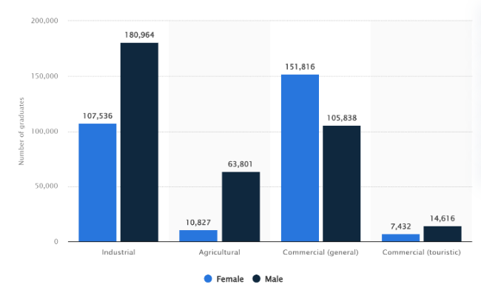
According to Statista, the number of technical and vocational education and training (TVET) graduates in Egypt as of 2021/2022 was around 640,000. Of these, 285,500 were specialized in industrial technical education, of which 62.7 percent were males, as shown in Figure 3. Moreover, Egypt includes 10 technological universities. Compared to a country like Germany, it has 17 technical universities, according to TU9. That indicates the lack of Egyptian technical education.
Figure 3
The number of TEVT graduates in 2021/2022 year
Causes:
- Quality of Education
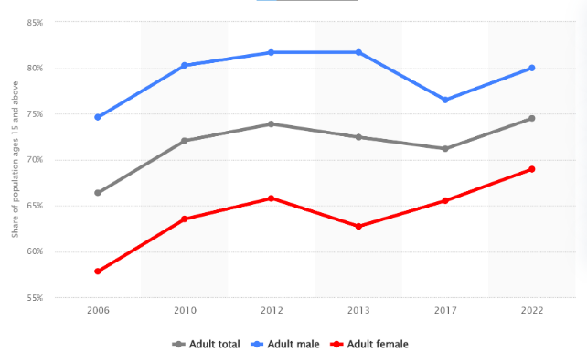
Later, the literacy rate in Egypt increased. However, as shown in Figure 4, it is still considered low compared to developed countries. There are some reasons for that low rate.
Figure 4
- Ancient curriculum: The curriculum in Egypt focuses on memorization more than critical thinking and problem-solving skills. It also depends on old concepts that are not beneficial nowadays.
- Private tutoring: According to ERF, on average, 40% of students receive private tutoring, and this percentage goes up to 60% for students at the secondary stage. 44% of students in urban areas take private tutoring, as opposed to 35 % in rural areas.

- Governmental schools’ quality
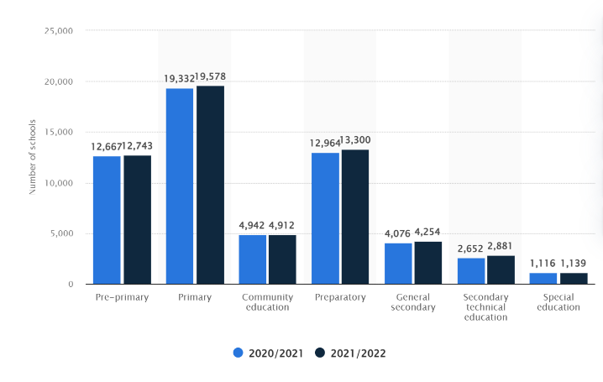
Due to the high number of Egyptian governmental schools and the low quality, as shown in Figure 5, private schools in Egypt contain approximately 10.6% of the total student population, according to CIRA. The number of private school students in Egypt has increased by 6.3% in the last five years, much more than the number of governmental school students, which increased by 3.6%.
Figure 5
Number of schools in Egypt as of 2021/2022, by educational level

- Technological and Digital Divide
In Egypt, the curriculum focuses on teaching old technological concepts, such as Windows 7 and old programming languages that are not significant these days. Moreover, many students, especially in rural areas in Egypt, don’t have access to technology outside Egypt, which negatively affects the future of the country. Some programs try to improve Egyptians’ knowledge, like the Digital Egypt Cubs Initiative, which about 7090 students enrolled in in March 2023, according to DECI, but it is still not enough to achieve a thriving society.
Impacts:
- High unemployment rate
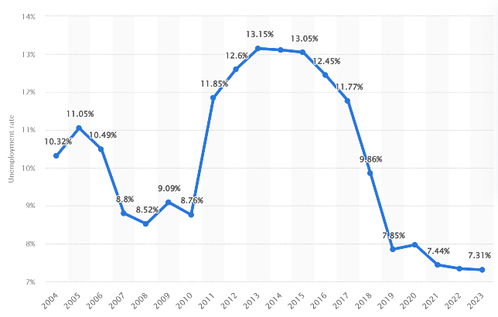
According to the technological advancement around the world, techno-logical jobs such as programmers and cyber analysists are required. And according to the digital divide in Egypt, not many people work in those fields.
Figure 6
Unemployment rate from 2004 to 2023 in Egypt
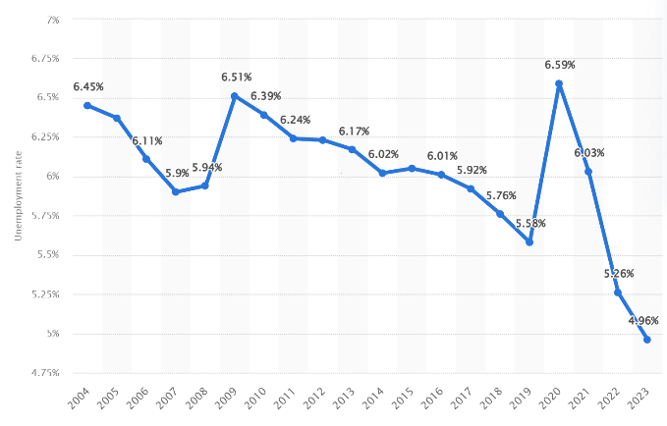
As shown in Figure 6, in 2023, the unemployment percentage in Egypt has reached 7.31% according to Statista. Which higher than the global unemployment percentage. As shown in Figure 7, the global unemployment percentage has reached 4.96% according to Statista.
Figure 7
Global unemployment rate from 2004 to 2023

- National security risks
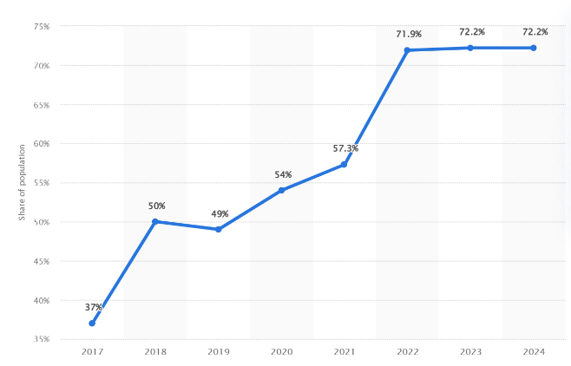
Egypt has weak cyber defence systems, which make banking, govern-ment, and infrastructure vulnerable to cyberattacks if there are not cyber- security workers to defend them. As of 2024, the internet penetration rate in Egypt reached 72.2 percent, up slightly from 37 percent in 2017, according to Statista, as shown in Figure 8. Additionally, cybersecurity threats rise as 90% of Egyptian companies face cyber risks (Egyptian Ministry of Communication, 2022).
Figure 8
Internet user penetration in Egypt from 2017 to 2024

- Cultural and knowledge impacts
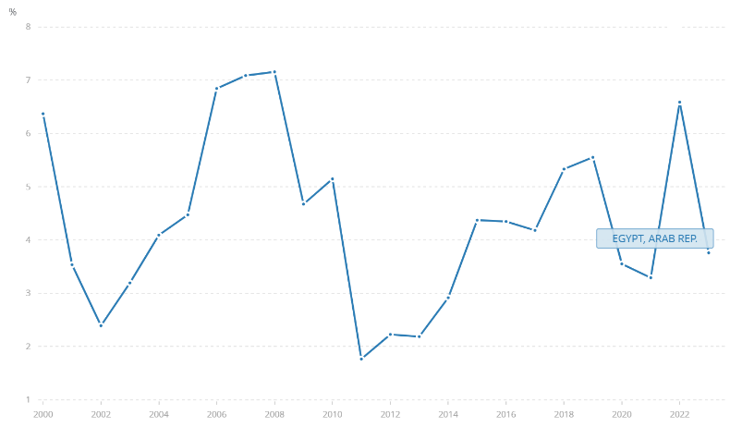
Only 30% of Egyptian students have access to digital learning tools and online websites, according to UNESCO in 2023. Additionally, research results in Egypt are low; therefore, Egypt ranks 86th among 132 economies in the Global Innovation Index 2023 according to WIPO. Also, Egypt advanced to the 55th position in the global Research and Development (R&D) sub-index, according to the 2023 Global Innovation Index report according to academy of research and technology.
Figure 9
GDP annual growth in Egypt

Address & reduce pollution in air, water, and soil.
Egypt faces several grand challenges that affect its economy and people. Pollution, whether in the air, water, or soil, is one of these problems. Therefore, finding a solution to these problems is significant. For instance, air pollution in Cairo according to the Clean Air Fund, 33% of Cairo's PM2.5 air pollution concentrations result from road transport. The second type of pollution is soil pollution, which affects farming and, as a result, will affect the economy. , 79.24% of the Middle Nile Delta appeared to mely elevated levels of heavy metal contamination with average concentrations reaching 132 units. The third type is water pollution. It has several negative effects on the country and its people, according to UNICEF, approximately 7.3 million Egyptians lack access to safe drinking water, with 5.8 million residing in rural areas and 1.5 million in urban centers, and around 12% of the population living in dwellings not connected to the water system, compared to 4% in urban areas.

In 2019, Egypt was ranked 56th among 98 countries for pollution, according to IQAir. Therefore, the government should solve the water pollution problem and other types of pollution. Egypt generates about 16.4 billion cubic meters(BCM) of wastewater annually, comprising 4.4 BCM of sewage and 12 BCM of agricultural runoff. This wastewater should be exploited. Generating renewable energy will have a positive effect on the Egyptian environment instead of using fossil fuels as a source of energy, according to the Ministry of Electricity and Renewable Energy, 85% to 90% of Egypt's electricity is generated from fossil fuels such as oil and natural gas, this means most emissions of greenhouse gases come from the burning of fossil fuels.
Therefore, the Egyptian government should solve this problem by reducing the emissions, specifically producing renewable energy and addressing and reducing pollution orders huge effort from people. Because the high percentage of people pollute the Egyptian environment, according to the Egyptian Environmental Affairs Agency EEAA, 10% to 15% of local pollutant levels are from open burning of waste. In the Egyptian countryside, many people are unaware of the impact of open-burning waste. Another crucial point is energy in Egypt, mostly generated by fossil fuels and a low percentage of renewable energy resources, as shown in Figure 10. The Egyptian government generates energy from renewable sources such as solar and wind at 8%, according to the International Energy Agency.
Figure 10: shows the percentage of sources of energy in Egypt.
Causes:
- Transport.
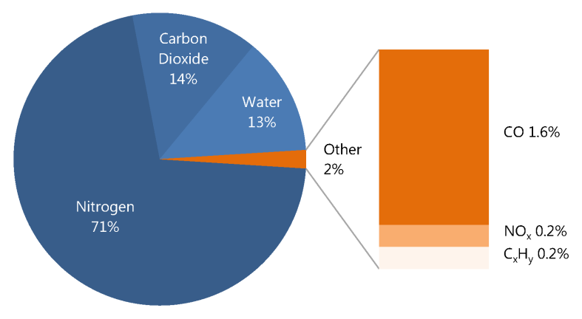
The main source of PM2.5 air pollution in the greater Cairo area is transportation, which accounts for 33% of the total, with an increasing percentage of private cars and taxis. This causes urban congestion problems at a percentage of 80%, and traffic volumes reach seven thousand 7000 vehicles per hour per lane, superior to the maximum theoretical flow of 1,900. This causes the emissions of greenhouse gases, specifically carbon dioxide, at percentages from 10% to 15%. Car exhausts contain several toxic gases that can cause global warming and can affect the climate in Egypt and any country. It contains carbon dioxide, CO2, carbon monoxide, water vapor H2O, nitrogen oxides NOₓ, and unburned hydrocarbons HC. The percentage of these gases is shown in Figure 11. Carbon dioxide and water vapor are greenhouse gases at 14% and 13%, respectively. They cause air pollution in the world and Egypt by contributing to global warming.
Figure 11: shows the percentage of car exhausts.
- Agricultural slash and burn.
Agricultural slash and burn causes several problems, including reducing oxygen and increasing carbon dioxide. According to the Egyptian Environmental Affairs Agency, agricultural burning contributes 5% to 15% of total particulate matter PM emissions, particularly in rural and peri-urban areas such as those in the Nile Delta. So, this is another cause of air pollution. According to the Egyptian Environmental Affairs Agency EEAA, in the Nile Delta, where crop residue burning occurs, the percentage of local carbon monoxide concentration can increase by 10%-20% relative to baseline levels.
- Throwing waste and industrial discharge into the Nile River.
The Nile River is the main source of water in Egypt. People use the water from it for drinking and making food. Therefore, throwing the rubbish into the Nile River causes pollution in the Nile River's water. This waste management is a big trouble faced by the Egyptian government. According to the United Nations Environment Programme UNEP, from 25% to 40% of municipal waste is either not collected or improperly managed. This uncollected waste is thrown into the Nile River and the local waterways. According to the Egyptian Environmental Affairs Agency EEAA, a significant percentage of industrial wastewater, estimated from 60% to 70%, is discharged into the Nile River without adequate treatment. This is because factories do not have the facilities to purify their wastewater. In many urban industrial areas, 80% of the wastewater is discharged without any treatment into the Nile River. This contributes to increased water pollution in Egypt and other countries along the Nile River.

Impacts:
- Diseases and disorders caused by polluted water.
According to the Egyptian Organization for Human Rights, approximately 38 million people drink polluted water, and the amount of untreated industrial pollutants that enter the water supply is estimated at 4.5 million tons per year. This can cause many diseases, such as cholera. According to the Egyptian Organization for Human, a significant percentage of poisoning cases are caused by pollution from different cities. 35% by Cairo, 12 % by Giza, and 50% by Qalyubia. This is shown in Figure 12. According to EEAA and other studies, approximately 100,000 people are diagnosed with cancer every year, and 15000 people get kidney failure. Also, there are other diseases attributed to water pollution in Egypt. From 10000 to 15000 hospitalizations annually, in dangerous areas where waterborne diseases, such as acute diarrhea, typhoid fever, and cholera.
Figure 12: shows the pollution in different cities in Egypt

- Reduced Soil Fertility.
According to the Egyptian Environmental Affairs Agency EEAA, heavy metal contamination stemming from industrial and municipal waste affects 15-25% of cultivated areas in the Nile Delta. In these affected areas, the reduction in soil fertility has been linked to a decline in crop yields of around 10–15% for some staple crops. This also affected farming and, as a result, affected the economy because the Egyptian government and the farmers couldn't exploit the agricultural land to plant the crops that need a high percentage of soil fertility. Soil salinity causes a reduction in soil fertility, but Soil salinity is caused by soil pollution. Salinization affects about 35% of Egypt's agricultural lands, particularly in the Lower Delta, limiting crop diversity to salt-resistant varieties like rice.
- Temperature strikes.
Climate change occurs because of the temperature change, whether decreasing or increasing, by greenhouse gas emissions such as carbon dioxide and methane emissions. This not only causes climate change but also global warming. According to the International Energy Agency (IEA), Egypt’s energy sector was responsible for roughly 250 million tons of CO₂ emissions in 2018. Climate change harms crops by causing reduced water availability and lower rainfall. As a result, agricultural lands are experiencing desertification.

Reduce and adapt to the effects of climatic change
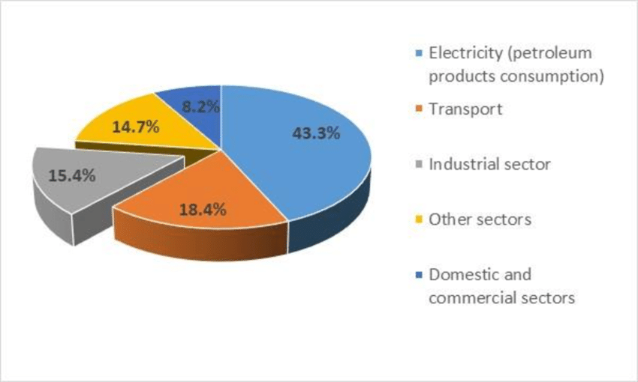
The issue of climate change has many negative consequences and effects on Egypt and its people. Therefore, Egypt deals with the issue of climate change with great interest and studies its developments in Egypt in particular and in the region in general. Also, Egypt is one of the countries most affected by the problem of climate change, whether it is on the rise or fall of extreme temperatures and other environmental damage. That is why everyone should deal seriously with this environmental problem and learn more about it and how to solve it. Since the very beginning of the history of this problem with Egypt, emissions of greenhouse gases have increased dramatically in Egypt, for example, carbon dioxide, as shown in Figure 13.
Figure 13

Work to eradicate public health issues
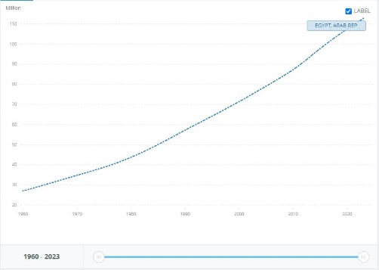
Infectious diseases are the world’s leading cause of morbidity and mortality. According to a report by the WHO at a global level, 7 of the 10 leading causes of death in 2021 were noncommunicable diseases, accounting for 38% of all deaths or 68% of the top 10 causes. The vector-borne diseases are caused by pathogens and parasites in human populations and account for more than 17% of all infectious diseases. Rapid population growth, such as in the case of Egypt, which has recently reached a population of 105,914,499 per capita in only 5% of the country’s surface area, as shown in Figure 14, multiplies the infection rates due to overcrowding and urban congestion. Behind these are factors like Poverty, Availability of health sectors, and personal hygiene. The impacts of these health issues are an economic burden and health sector overload, in addition to social and demographic changes.
Figure 14: population growth in Egypt

Causes:
- Low-Income
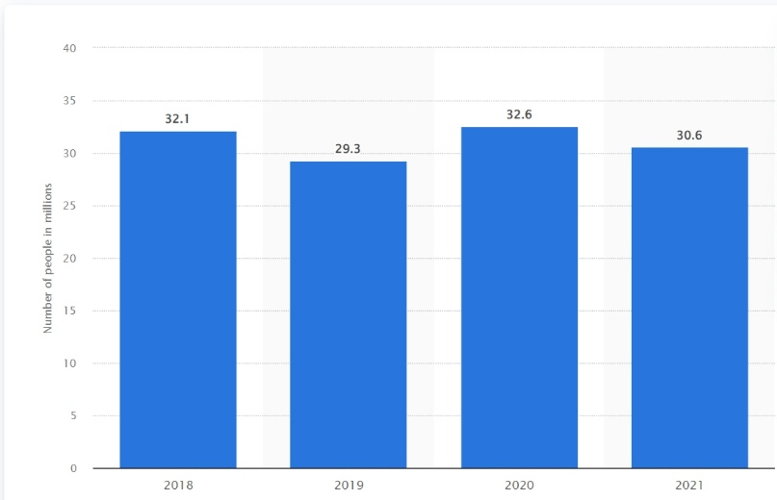
Income affects the public health sector; the leading cause of death for people living in a low-income country is communicable diseases, as 8 of the top 10 causes of death in 2021 in low-income countries were communicable diseases. Poverty affects access to medicine and health services, which affects a country with a poverty percentage of 30.6% as of 2021, as shown in Figure 15. Furthermore, chronic diseases due to genetic code are harder to fully eliminate and require genetic technology like Gene Therapy, which is limited and highly expensive; as of 2021, there were only 15 approved gene therapy products. Access to approved therapies remained limited in LMICs and is exclusively through managed access and compassionate programs.
Figure 15
NO. of people living under the poverty line in Egypt from 2018 to 2021

- Accessibility to public health.
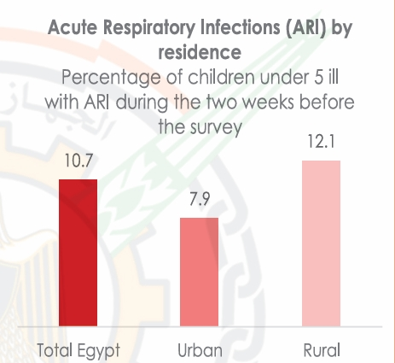
Public health accessibility is another factor controlling the spread of infectious diseases. Egypt has the largest population in North Africa, with a population of 105,914,499 per capita as of 2024. This makes up 1.3% of the world’s population, congested along the Nile banks and delta, which only makes up 5% of Egypt’s surface area of approximately 1 million square kilometers. As a result, 95% of Egyptians live in 5% of the country. This urban congestion increases diseases, especially acute respiratory infections, as shown in Figure 16.
Figure 16
Acute Respiratory Infections (ARI) by residence

- Personal Hygiene
In 2014, around 91 percent of the Egyptian population had access to water in their houses. However, a significant number of households are still not connected to the water system in rural areas and urban slums. 7.3 million people are deprived of access to safe water, among which 5.8 million live in rural areas and 1.5 million in urban areas. In rural areas, around 12 percent of the population lives in dwellings not connected to the water system, while in urban areas, 4 percent do not have a water connection. They are usually located in urban slums and poor settlements. Such individuals don’t have access to clean water needed for personal hygiene, which increases infections and public health issues.

Impacts:
- Economic Burden
Health issues, disease outbreaks, and chronic diseases increase the burden on the healthcare spending of the state. Egypt’s health expenditure reached 4.61% of its GDP in 2021, reaching a maximum of 5.51% in 2001 and 5.31% in 2017, as shown in Figure 17. The government spending on health has reached this percentage due to disease outbreaks and the increasing healthcare requirements due to the increasing population Egypt has a population growth rate of 1.7% (as of 2023) as shown in Figure 18 and the population went from 27M to 112M in 63years with 414% increase in population as shown in Figure 19. The increasing population ultimately caused healthcare prices to rise significantly, as shown in Figures 17 and 18. Disease outbreaks and health issues cause serious damage in highly populated and congested areas.
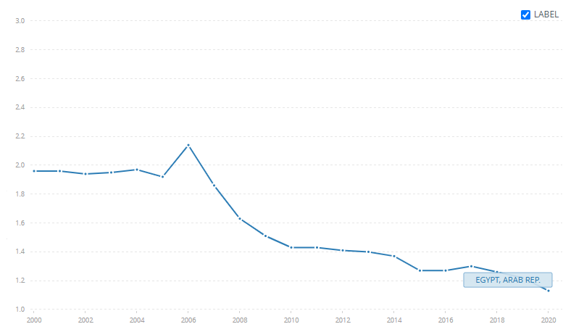
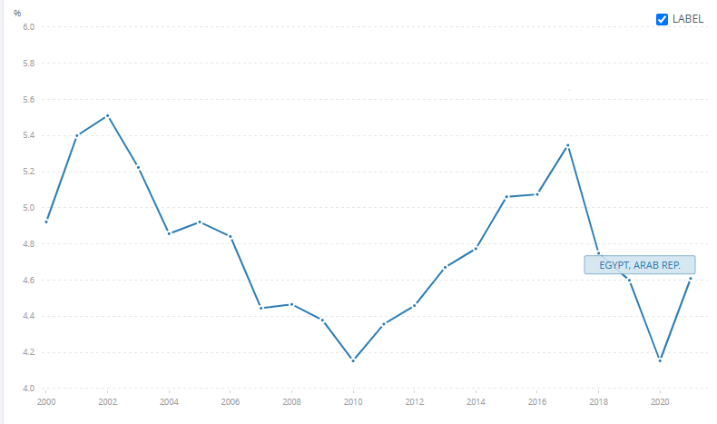
Figure 18
Population growth (annual %) - Egypt, Arab Rep.
Figure 17: Egypt’s health expenditure in % of GDP, source: World Health Organization Global Health Expenditure database ( apps.who.int/nha/database )
- Overload on public health sectors
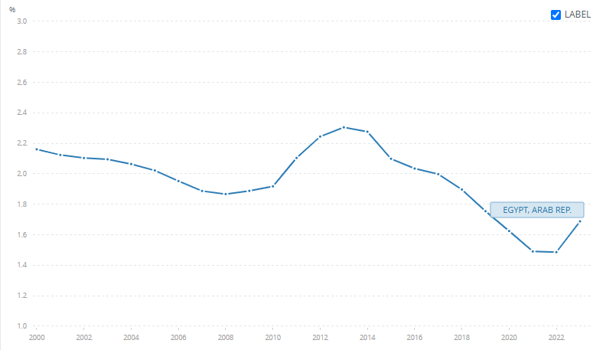
Overcrowding and population congestion have been an issue in Egypt since the mid-20th century. Egypt has grown from 22 million in 1950 to 104 million in 2024. This resulted in multiple other problems, one of which was an overload of public health services. Public health services in Egypt can be divided into public hospitals, vaccination programs, and local medical centers. These public services are overloaded and cannot provide support for all individuals due to urban congestion and population growth. This can be seen, for example, in the Cairo Metropolitan Area, which has a population density of 40,000 people per square kilometer: up to 100,000/sq km in older districts and a population of 20 million people, which makes up 20% of Egypt’s total population. This area has 0∙23 health facilities per 10000 population and 1.4 governmental hospital beds per 1000 people as of 2014, as shown in Figure 19. This high population density, insufficient number of healthcare centers, and number of hospital beds ultimately lead to overloading the public health sectors.
Figure 19: Hospital beds (per 1,000 people) - Egypt, Arab Rep.

- Social and demographic changes
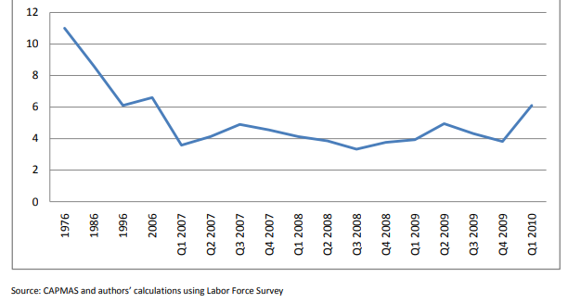
Disease outbreaks in rural areas of Egypt, where there is a lack of government and health services, encourage the rural population to move to the cities to escape the disease outbreak and utilize the more abundant healthcare infrastructure in the city. As a result, in addition to other factors like lack of services and lack of job opportunities, internal migration reached 4% between 2007 and 2009 and increased to 6.1% in Q1 2010, which can be seen in Figure 20. This leads to more pressure and overload on the healthcare system there and leads to more disease outbreaks across the country.
Figure 20: Internal migration rate in Egypt

Problem to be solved
Reducing Power Shortage Through Alternative Energy
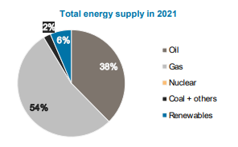
Non-renewable energy sources, being the backbone of Egypt’s industrial sector, are an expensive, inefficient, and limited source of energy. As of 2021, 94% of Egypt’s energy supply is considered to be non-renewable 2021, with gas at 54% and oil at 38%, as shown in Figure 21.
Figure 23: Egypt's total energy supply in 2021

With 1,066,747 (TJ) imports and 871,586 (TJ) exports, Egypt has a net energy trade of -195,161 (TJ), which increases energy costs in Egypt, increasing the prices for Egyptian consumers and reducing the net amount of distributed energy due to the cost of importing or producing energy.
The heavy load on the economy due to the increasing energy requirements is also due to the prices of imported non-renewable resources like oil, which has an average price of $76.48/bbl. Natural gas has an average price of $5.75/MMBtu, which increases pressure on the national income. Furthermore, this energy storage leads to an unfair distribution of electricity across cities; this can be seen in Nouba, South Sinai, which is located among tourist hotels, villages, and restaurants that get the majority of electricity and most infrastructure maintenance.
The power shortage issue in Nouba is caused by several factors, which are low-quality electricity infrastructure, high prices of non-renewable energy, and bad utilisation of renewable energy
Positive Consequences
- Lower Oil Prices
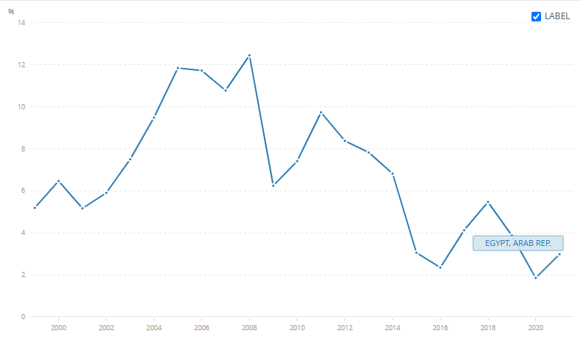
Egypt has a power score of 1.82, which puts it at rank 65 in the Emerging Markets power ranking. In comparison to 2023, Egypt has dropped in the power rankings by 25 places, from rank 40 to rank 6. This drop in ranks is due to dependence on non-renewable sources such as fossil fuels. The price increases rapidly; for example, Oil rents are the difference between the value of crude oil production and the costs of producing it. Oil rent has increased to 3 in Egypt in 2021, as shown in Figure 22.
Figure 24: oil rent in Egypt

The high demand for fossil fuels such as oil and natural gas combined with the low supply of said fossil fuel has increased the prices of fossil fuels, thus increasing the load on Industry and Military sectors which require large amounts of fossil fuels.

Utilizing renewable energy resources such as wind energy, solar energy, and hydropower would decrease the residential demand for fossil fuels, largely decreasing the demand for fossil fuels and thus decreasing the fossil fuel price for all public sectors.

- Reduced Electricity Prices
The current dependence on non-renewable energy sources in Egypt, like oil and natural gas, has caused electricity prices to increase. For example, reports announced in January 2024 have shown an increase ranging between 10 and 40 per cent for different brackets, with the highest shouldering the largest hike in Q1 2024.
The rate for the first bracket, covering consumers of between 0 and 50 kWh, has increased from LE0.58 to LE0.68 per kWh.
The second tier, covering consumption from 51 to 100 kWh, is now LE0.78 per kWh, up from LE0.68. For the third bracket, when consumption exceeds 100 kWh and reaches up to 200 kWh, the rate rises from LE0.83 to LE0.95.
Consumption surpassing 200 kWh falls into the fourth bracket, which goes up to 350 kWh, with an increase from LE1.25 to LE1.55 per kWh. This pattern of price increase also continues on higher consumption, according to the report.

Utilizing renewable energy, such as wind energy, can solve such problems by increasing the local production of electricity, which would lead Egypt to have a power surplus instead of a deficit.

- Less Pollution
Fossil fuel power generators are major pollutants to the air. The air contains three major pollutants that are harmful to the environment: carbon monoxide, nitrogen dioxide, and carbon dioxide. Fossil fuel plants and industrial sectors are the main producers of said gases. Furthermore, car emissions contribute to 33% of the air pollution in Egypt, This is because electric vehicles only make up 0.1% of car sales, therefore, 99.9% of cars in Egypt depend on fossil fuels, which not only increases air pollution but also increases oil prices.
As a result, Egypt is in the 12th position in the global pollution index and 9th in air pollution. Expanding the use of renewable energy sources would decrease the air pollution through reducing the importance of fossil fuel power generators and later fully replacing fossil fuels, thus reducing pollution while also reducing demand for fossil fuels.
Negative Consequences
- Limited Industrial Capacity
Due to the high prices of fossil fuels, for example natural gas that has reached $5.75 per million British thermal units, combined with the price of moving such fuels across large areas of land to locations such as South Sinai, the cost of implementing industrial improvements in such areas is costly, and often ignored despite the possibilities of said locations in areas of rock mining or other industrial sectors.
- Unfair Infrastructure Distribution
Fossil fuels require large power generators, usually around the center of the country or outskirts of central cities, and these generators require a large infrastructure, both underground and above the ground, to be transported to cities. The high cost of the required infrastructure can limit the reach of fossil fuel-generated electricity to certain main locations in Egypt.
As a result, electricity reaches in far locations such as South Sinai is limited, damaging the economy and social life.
- Economic Loss
Egypt also has a large water supply through the Nile with an annual share of around 55 m3 billion. However, the water supply, fertile soil of 2.3 million ha, and industrial opportunities such as mineral extraction, building material extraction, food industries, and manufactures are not utilized to the fullest extent. This is because the energy required to fully exploit such resources is too expensive, making the process unprofitable. This reduces job opportunities and local income, ultimately causing economic loss in the country.

Research
Topics related to the problem
- Air pollution in Egypt.
One of the main problems worldwide is the main cause for climate change, and it’s mainly caused in Egypt by generating power through fossil fuels and non-renewable sources, which is why researching it is important for identifying our problem.
When research has done on pollution in Egypt it’s found that Egypt is ranked the 9th in air pollution And Egypt holds the 12th position in the global pollution index, with a score of 82.7, making it one of the most polluted countries in the world. Cairo itself scores 95.8 out of 100, 10 times above the safe limits, being globally one of the most polluted cities in the world.

- Electricity mix in Egypt.
Egypt has several ways of generating electricity. Although Egypt still uses non-renewable sources of energy for the main electricity generation. Most of Egypt’s energy comes from fossil fuels, consisting of oil and gas, and searching for how the share is distributed between the Energy sources is fundamental to finding the problem.
After research, it was found that 81% of power generation in Egypt is from gas, 7.5% from oil, and 11.5% from renewable and low-carbon sources such as wind, solar, and hydropower, where the consumption of energy in Egypt is 1540 kWh of electricity. Energy production in Egypt is around 3,850,000 TJ. The energy production from polluting sources is around 3,380,000 TJ, which is a massive problem as only the CO2 emissions are around 217.806 Megatons, reaching 118% increase from 2000 to 2022, and 0.6% of the global emissions according to IEA.

- Power shortage in South Sinai.
One of the areas most affected by power outages in Egypt is South Sinai. Especially in the outskirted villages, which makes them the best places to consider and research in the process of deciding our problem.
After searching about the power shortage in South Sinai, it is found that there are Infrastructure Limitations as some areas within South Sinai have aging electrical infrastructure, which can lead to occasional faults and outages. As well as that, Regular maintenance and upgrades to the power grid can necessitate temporary shutdowns, affecting local communities and businesses. While there are Technical Issues. Unforeseen technical problems, such as equipment failures or grid imbalances, can cause sporadic power interruptions.

Topics related to the solution.
- Alternative energy sources.
The exploration of alternative energy sources is important to solving power shortages in Egypt. By reducing dependence on fossil fuels. Researching this topic will contribute to economic growth, environmental preservation, and energy security, making it essential for solving our problem.
In Egypt, renewable energy sources accounted for only 11.5% of total electricity generation in 2023, while 77% was derived from natural gas. Solar and wind energy potential is vast, with an estimated 6.5 kWh/m² daily solar radiation and wind speeds reaching 10 m/s in certain regions. However, investment in renewables remains limited, with only $2.8 billion allocated in 2022. By increasing reliance on alternative energy, power shortages in Egypt can be mitigated.
- Solar power generation.
The study of solar power generation should be made to reduce power shortages in Egypt. With increasing dependence on fossil fuels, Solar energy offers a sustainable and abundant source of electricity. Researching this topic is very important to choose the best possible solution.
Egypt has an average solar radiation of 6.5 kWh/m²/day, making it one of the most suitable countries for solar power generation. Despite this potential, solar energy contributed only 4.5% to Egypt’s electricity mix in 2023. The Benban Solar Park generates 1.8 GW. With power consumption exceeding 180 TWh in 2022 and peak summer shortages lasting up to five hours daily, expanding solar power generation is crucial for reducing electricity outages.

- Wind power generation.
The study of wind power generation is important as a solution to Egypt’s power shortages. Wind energy provides a renewable, cost-effective, and sustainable solution. research and expansion of wind power will contribute to solving our problem.
Egypt has high wind energy potential, as wind speeds reach 10 m/s in areas like the Gulf of Suez. In 2023, wind power contributed only 3.7% to the national electricity mix, despite the country’s goal of reaching 42% renewable energy by 2035. The Zafarana and Gabal El-Zeit wind farms generate around 1.6 GW, but electricity demand exceeded 180 TWh in 2022, leading to summer outages. wind power is essential to mitigate energy shortages and make a stable electricity supply.

Other solutions already tried.

Dogger Bank Wind Farm
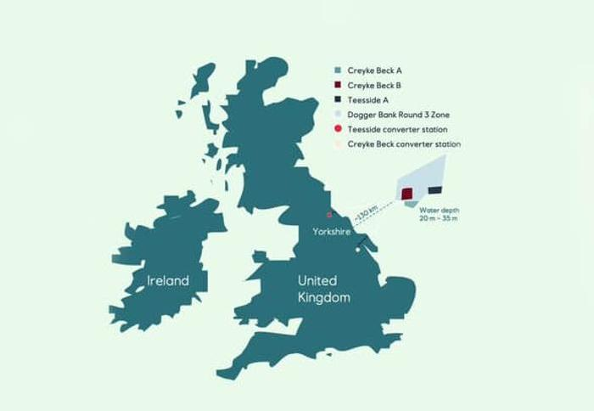
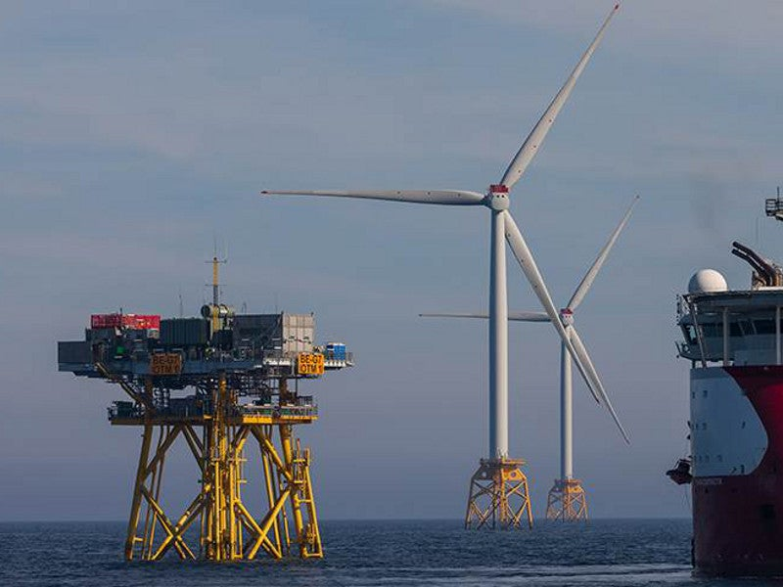
Dogger Bank Wind Farm is a facility built to generate electricity from the wind in the United Kingdom, as shown in Figure 23. It is divided into 3 parts: Dogger Bank A with 95 wind turbines, Dogger Bank B with 95 wind turbines, and Dogger Bank C with 87 wind turbines. According to the Society of Operations Engineers (SOE), it was built on the northeast coast of England. It is located in the North Sea approximately 70 nautical miles, and it stays away 130km off the coast of Yorkshire, as shown in Figure 23. It is an offshore wind farm using Horizontal wind turbines, specifically GE Haliade-X wind turbines. The construction of Dogger Bank Wind Farm started in 2020, It is a joint venture between three companies, which are SSE Renewables UK- 40% stake, Equinor Norway -40% stake, and Vårgrønn Norway- 20% stake. In 2026, it will generate electricity to power around 6 million UK homes. According to the Society of Operations Engineers (SOE), the height of the huge turbines in the Dogger Bank Wind Farm is 260 meters. This height can help increase the power output of the horizontal wind turbines. Dogger Bank Wind has a total capacity of 3.6 GW. Another important point is that the water depth in the Dogger Bank Wind Farm is from 20 m to 35m, making it suitable for fixed-bottom wind turbines. This depth is specifically in tranche B.
Figure 23: Map of Dogger Bank Wind Farm
Figure 24: shows the Dogger Bank Farm

Mechanism
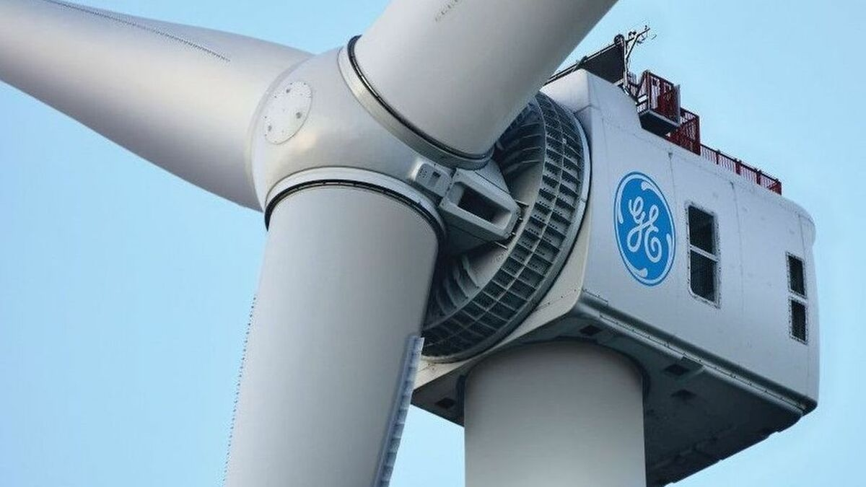
Firstly, the type of wind turbine is horizontal wind turbine, specifically GE Haliade-X, as shown in Figure 24. The Haliade-X has 3 massive blades. The blades are attached to a hub. The GE Haliade wind turbines use a direct-drive gearless system. The blades are connected to a permanent magnet generator. After that, the generator converts the rotational kinetic energy into electrical energy. This is the generator system. The GE Haliade wind turbines don’t have a gearbox. It uses a direct-drive gearless system.
Secondly, the direct drive gearless system. Traditional wind turbines use a gearbox to increase the rotational speed before sending it to the generator. The direct drive skips this step by connecting the rotor directly to the generator, making the process more efficient. It works in four phases. The first phase is rotating the blades by the wind. The height of the blades in the Dogger Bank Wind Turbines is 107 meters. Therefore, they capture the wind efficiently and begin rotating. The rotors rotate slowly, typically at 5–12 revolutions per minute. The second phase is turning the generator directly with the rotors. Instead of passing through a gearbox, the main axis is directly connected to a permanent magnet generator. This generator revolves at the same speed as the rotor. The third phase is generating electricity by the permanent magnet generator. It uses rare-earth magnets to generate a magnetic field. As the rotor moves, the magnetic field interacts with the copper coils inside the generator, creating an electric current. In the end, this process effectively converts mechanical energy to electrical energy. The last phase for distribution in the United Kingdom is stepping up the voltage for transmission of the electricity. Electricity is initially generated at a low voltage. So, the voltage needs to be increased for efficient transmission.
Figure 24: A picture of Haliade wind turbine
Finally, the electricity is translated by the high-voltage direct current cables. Then the electricity is transported by those cables 130 km to the UK mainland where it is distributed to the homes and companies. This is a mechanism for generating electricity by the GE Halaide-X turbines.

- Points of strength
- Direct drive (gearless) system in the Haliade wind turbines.
This system does not use a gear system. So, it reduces maintenance costs and mechanical wear. And allows for high efficiency. The gearbox in the wind turbines causes traditional issues, which are high maintenance costs and high mechanical wear. Also, the direct drive system uses a permanent magnetic generator that directly converts the mechanical energy to electrical energy. This provides lower energy loss and high efficiency. Also, the design of the direct drive system provides more reliability and efficiency. Another important point is that the gear system produces noise and vibrations. On the other hand, the direct drive system is smoother and quieter. Also, the direct drive system is perfect for offshore environments, particularly in the North Sea where the Dogger Bank Wind Farm was built, because it produces low maintenance costs and the maintenance in offshore environments is difficult and expensive. And fewer moving parts in the direct drive system means less stress and lower failure rates.
- High power output from Haliade wind turbines.
The Haliade wind turbines generate up to 14 MW for each one, with some variants reaching 13 MW in the Dogger Bank Wind Farm. Therefore, they produce a significant amount of energy that can be enough for 6 million houses in the United Kingdom, whereby, each turbine can generate enough energy for 16000 British houses. This contributes to a total wind farm capacity of 3.6 GW, providing 5% of the UK’s electricity demand. Their high power output is due to a collection of advanced designs, large sizes, and modern technology.

- Large rotor and blades for maximum wind capture.
The large diameter of the rotor blades helps capture more wind energy. The rotor diameter of each rotor on the Dogger Bank Farm is 220m. Therefore, it is the largest offshore wind turbine in the world. Also, the blade length is 107 meters, which allows for efficient energy production even at low wind speeds. The swept area is 38,000 m². So, this is a large swept area that increases the turbine’s ability to harness wind energy. The swept area is important because the amount of energy captured depends on the swept area. Also, large rotor blades help increase the power output of the wind turbines. Also, the turbine with big rotors can generate more electricity with fewer turbines. As a result, this reduces the cost and space demand for wind turbines.

- Points of weakness.
- Environmental and Marine Ecosystem Impact
The construction and operation of offshore wind farms can disrupt marine ecosystems by affecting fish populations and seabird migration patterns. Also, noise and vibrations from turbine installation, such as pile driving, can disturb marine mammals like whales and dolphins. The turbine and maintenance ship increase human activity in remote ocean areas, which may affect fishing industries and local marine biodiversity. Therefore, offshore wind turbines should be designed carefully to minimize environmental harm. Another important point is that the Dogger Bank area is a vital habitat for fish species, crabs, and other marine life, which may be disrupted or destroyed. Also, turbine foundations change the seabed conditions. This affects the feeding and breeding patterns of certain species. As a result, wind turbines in this area can cause damage to the marine environment.
- Limited Operational Efficiency in Extreme Weather.
The Haliade wind turbines are designed for high efficiency, but they must shut down if the wind speed exceeds 25 m/s to prevent structural damage. So, this is the trouble, because the Dogger Bank region experiences stormy weather in the winter, which causes temporary shutdowns and reduces electricity production. Also, icing on the blades in extremely cold conditions reduces the aerodynamic efficiency and leads to power losses. Another important point is that exposure to saltwater leads to corrosion and may affect the performance of the turbine in the future. In the end, extreme weather is related to shutdowns and efficiency losses. This reduces the reliability of power generation.

- Large Size Creates Logistical Challenges.
The turbine’s nacelle is massive, weighing over 600 tons, and the blades are 107 meters long, making transportation and installation logistically difficult. Only a few ports and vessels in the world are capable of handling turbines of this size, and the sheer scale of Haliade-X wind turbines limits where they can be installed, making distribution more complex and expensive. Therefore, the huge size of the horizontal wind turbines in the Dogger Bank Wind Farm can cause some problems that affect the cost and maintenance of the turbines.

Benban Solar Park
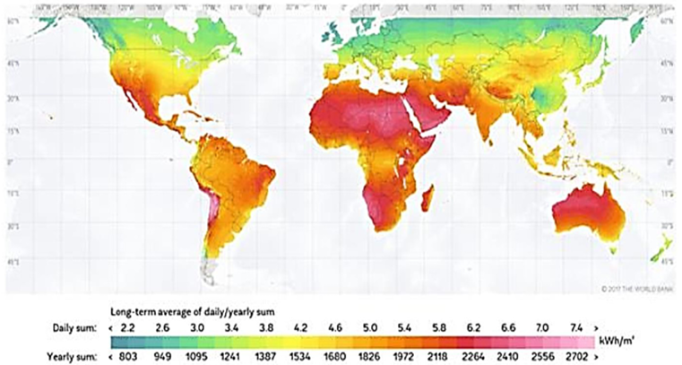
Egypt has established the largest solar power plant in the world in Benban village, Aswan. The Benban village is located in the western desert at a latitude of 24.26⁰ N and a longitude of 32.43⁰ E, 40 km north of Aswan and 650 km south of Cairo. The location of the Benban solar power plant is selected by the studies and reports by NASA and several international scientific institutions, which emphasize that the project site is one of the sun's brightest regions around the world. A satellite photo is shown in Figure 25. The Benban Solar Park is designed with a total capacity of 1600 MW covering an area of 37.2 square kilometers, and it is divided into 32 sub-systems. Egypt planned to extend the total capacity of Benban Solar Park to 2000 MW from 40 sub-systems. The sub-systems are divided into four groups titled plant-1, 2, 3, and 4 and each plant consists of eight sub-systems with almost 50 MW AC. The four solar PV power plants are connected to the Egyptian high-voltage network through four transformer stations titled Benban-1, Benban-2, Benban-3, and Benban-4. Benban Solar Park, as a part of the Egyptian Fit program, is the most immense national energy project in renewable resources.
Figure 25: concentration of the daily sun.
Figure 24
Mechanism:
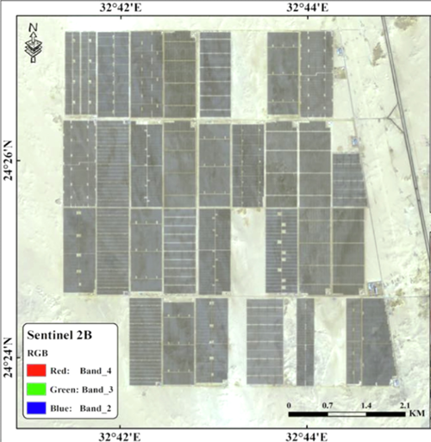
Egypt is geographically located between latitudes of 22⁰ N and 31.5⁰ N and longitudes of 24⁰ E and 37⁰ E, thus, it is situated in the central position of the global solar belt, as shown in Figure 26.
Each sub-system with a capacity of 50MW AC that is constructed on an area of 1600*600m2 is divided into 12 blocks; each one contains a number of trackers and two models of inverter, i.e., GrowattCP2000 Station-S and GrowattCP2520 Station-S. The main components for each 50MW AC sub-system are shown in Figure 26.
Figure 26
The sub-system contains approximately 192,510 PV modules and 24 inverters to convert the direct current (DC)output of the solar photovoltaic modules into alternative current (AC) that is connected to the national grid electricity transmission system.
Figure 27: Rear view of trackers
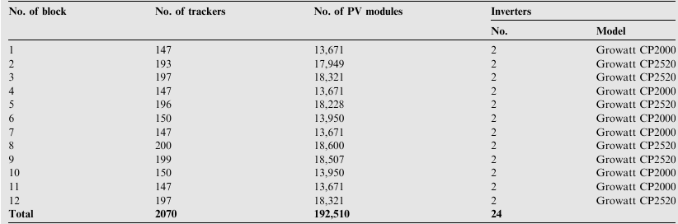
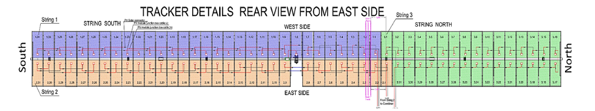
Figure 27 shows the schematic diagram of the tracker system in a 50MW sub-system that is divided into three strings, where each one contains 31 PV modules connected in series. Then, the combiner collects the direct current and the voltage output from the strings. The designed inverters have specified features to maintain the required adaption to use in the Benban Solar Park such as automatic synchronization, high conversion efficiency, anti-islanding protection, and maximum power point tracker. In the present project, the power point tracker efficiency that is defined as the ratio between the ideal power supply to the inverter and the power converted by the inverter is maximized.
Figure 28
Components of the AC sub-systems.

Points of strength:
- Renewable Energy Contribution
Benban Solar Park generates 1.8 GW of clean energy, supporting Egypt’s goal of 42% renewable energy by 2035. The abundant solar radiation in Aswan it helps reduce dependence on fossil fuels and enhances energy security, positioning Egypt as a leader in solar energy in Africa and the Middle East.
- Economic Benefits
The project attracted over $2 billion in investments, creating 10,000+ jobs during construction and supporting local businesses. It reduces reliance on expensive fossil fuel imports, stabilizes electricity costs, and strengthens Egypt’s role as an emerging renewable energy hub, fostering long-term economic growth and energy independence.
- Environmental Impact
Benban Solar Park cuts CO₂ emissions by 2 million tons annually, reducing air pollution and combating climate change. By replacing fossil fuel-based power generation, it conserves natural resources and promotes sustainability, helping Egypt transition to a cleaner, greener energy system while preserving biodiversity.

Points of weakness:

- Land Use Challenges
The 37 km² solar park occupies vast desert land, raising concerns about potential alternative uses such as agriculture or urban development. Additionally, harsh desert conditions lead to dust accumulation on panels, requiring frequent maintenance and increasing operational costs, impacting long-term efficiency.
- High Initial Costs
Despite long-term benefits, Benban required significant upfront investment for solar panels, inverters, and grid infrastructure. Heavy reliance on international funding poses risks for future expansions, while ongoing maintenance and technology upgrades add to the financial burden of sustaining large-scale solar energy production.
- Grid Capacity and Transmission Limitations
Egypt’s electricity grid struggles with intermittent solar power, as Benban cannot generate energy at night. Lack of large-scale battery storage reduces reliability, and grid infrastructure needs upgrading to handle high solar output efficiently. Strengthening transmission networks is essential for maximizing renewable energy integration.

Aswan High Dam
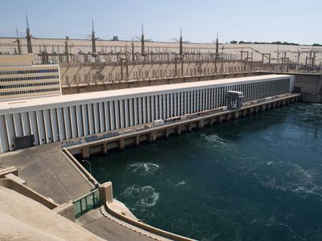
The Aswan Dam, shown in Figure 1, is built on the River Nile, just south of the city of Aswan in Egypt, and was completed in 1970.It is a rock-fill dam of 42 million cubic meters volume. The dam was constructed between 1960 and 1970. It aimed to increase the amount of hydroelectric power and regulate the flooding of the Nile, making it safer for agriculture around the Nile banks and increasing agricultural production. The Aswan High Dam is 3,830 meters long, 980 meters wide at the base, 40 meters wide at the crest (the top), and 111 meters tall. It contains 43 million cubic meters of material. At maximum, 11,000 cubic meters per second of water can pass through the dam. The reservoir, named Lake Nasser (named after Egypt's president at the time), is 550 km long and 35 km at its widest, with a surface area of 5,250 square kilometers. It holds 111 cubic kilometers of water. The bridge was constructed at a cost of about $1 billion. The Aswan High Dam captures floodwater during rainy seasons and releases the water during times of drought. The dam also generates 10 billion kilowatt-hours of electricity every year.
Figure 5: Aswan High Dam
Mechanism
The Aswan High Dam generates electricity through a hydropower system. Firstly, the dam creates a large reservoir of water, in this case lake Nasser, then once the bridge starts generating electricity it releases the water into large tunnels called penstocks. The water flows downwards because of gravity and pressure increases as it travels through the penstocks. This high-pressure water then moves the turbine blades, causing the turbine to spin and rotate connected generators which generates electricity. After the electricity is generated, it is transmitted by high voltage power lines to the power grid. The power plant at the Aswan Dam has a nominal capacity of 2,100 MW and is thus the largest power plant in Egypt. In 2015, the dam produced 5.68% of the Egyptian electricity supply and the production of electric power from the High Dam is 10 milliard kwh annually, which is double the amount generated in Egypt before the construction of the Dam.

Points of Strength
- Increased Agricultural Production
Aswan High Dam has allowed farming to continue, even during drought years e.g. 1972 and 1973. This reduced the dependency on food imports. Furthermore, 3.4 million hectares have been irrigated by the Nile, which increased the agriculture output of Egypt

- Flood Control
The High Dam limited the floods that hit the Nile Banks and ruined crop production in upper Egypt by blocking any incoming flood waves, it also saved lives in 1965, 1965, 1975 and 1987. Also, less flooding means that there are no flood repair costs, and insurance premiums are also cheaper.

- Economic Benefits
The construction of the Aswan High Dam provided job opportunities to workers, engineers and construction companies used in constructing the dam. Furthermore, the maintenance of the Dam provided stable jobs for more Egyptian workers and The Dam itself has become an important tourist attraction along with the temples that line the river, which increases the overall income and economic benefit of this Dam.

Points of Weakness
- Demographic Changes
Up to 100,000 Nubian (indigenous Egyptians) were forced to move from their ancestral homes. This damaged the Nubian Culture in Egypt and triggered multiple Nubian revolts to prevent the Dam from getting built.

- International Conflicts
Currently Egypt and Sudan get 90% of the Nile's water. Other countries that the Nile flow through are unhappy and have asked for more. This could lead to conflict, such as conflict between Egypt and Ethiopia and other countries along the Nile River.

- Environmental Impacts
Fertilizers, chemicals and waste is no longer flushed away by the Nile's annual floods. This is because of the High Dam’s structure as it only allows passage of water. Furthermore, it is estimated that $100 million worth of artificial fertilizers have to be used every year to replace the nutrients (alluvium) trapped behind the dam. This obviously has an economic cost, but there is also the environmental cost of using chemicals and possibly the social cost of people consuming the chemicals.

